IntuneAutomate Configuration 1
IMPORTANT: Please create and maintain the same SharePoint List names, Power Automate flows, variables and other naming assigned by the scripts and setup guidance otherwise the App may not work as designed.
Please follow the full setup instructions in the order provided. Skipping steps is likely to lead to erros and problems running the Application.

Pre-requisites:
M365 E3 or E5 license
Power Automate Premium
Power Apps Premium
Global Admin permissions

SharePoint and App Registration
- Create a new SharePoint Site ‘IntuneAutomate’ (Choose a private Team site > ‘Standard Team’ template)
  - Key in the site name as ‘IntuneAutomate’
  - Skip additional users
  - Import GitHub SharePoint Lists (Important use the same List Names provided) – The Lists are CSV files with schemas to maintain the SharePoint field type so default data imports correctly - so these have to be imported separately.
- Set an azure App registration with the included permissions using the attached PowerShell 7 script – ‘AppReg Setup - IntuneAutomateRunOnceSetupV1.
  - Check App reg details are added to the AutomateSettings Sharepoint List
- (Optional ) Open and update the ‘AutomateSettings’ SharePoint list to reflect your own App environment. Fields such as TenantID, ClientID and AppSecret are required but you will be prompted for these when you run the IntuneAutomate App for the first time. This includes populating details such as the company name, domain and url for your SharePoint site.

Power Automate flows & Power App
- Open your Power Automate environment (make.powerautomate.com) as an administrator with permissions and import the Power Automate and Power App solution provided on GitHub.
  - During the import when prompted sign-in to the individual connections using your own tenant admin account – This is the account they will under – These are presented before clicking ‘Next’
  - When presented with variables change ‘varAutomateList’ to your own Sharepoint site address i.e ‘https://YourSharepointDomian.sharepoint.com/sites/IntuneAutomateProd’
  - Check through your imported Power Automate imported flows and turn these on as well checking their connections. When happy move on to the next step.
- Run PowerAutomate Flow – ‘RunOnceIntuneAutomateSetupGroups’ This will create 2 Intune mail enabled groups -IntuneAutomate_Admin and IntuneAutomate_Manager and assign your account to IntuneAutomate_Admin group. Check your account has been added.
- Open your Power App environment (make.powerapp.com) with admin permissions and import the IntuneAutomate Power App solutions using the menu option > Solutions (The solution imports the IntuneAutomate App and linked App Power Automate flows). When Testing it’s recommended to import into a test environment.
- Now run the App for the first time – You will be prompted with multiple connections used by the app. Click ‘Don’t Allow’ these to progress. See steps below why and how to setup.
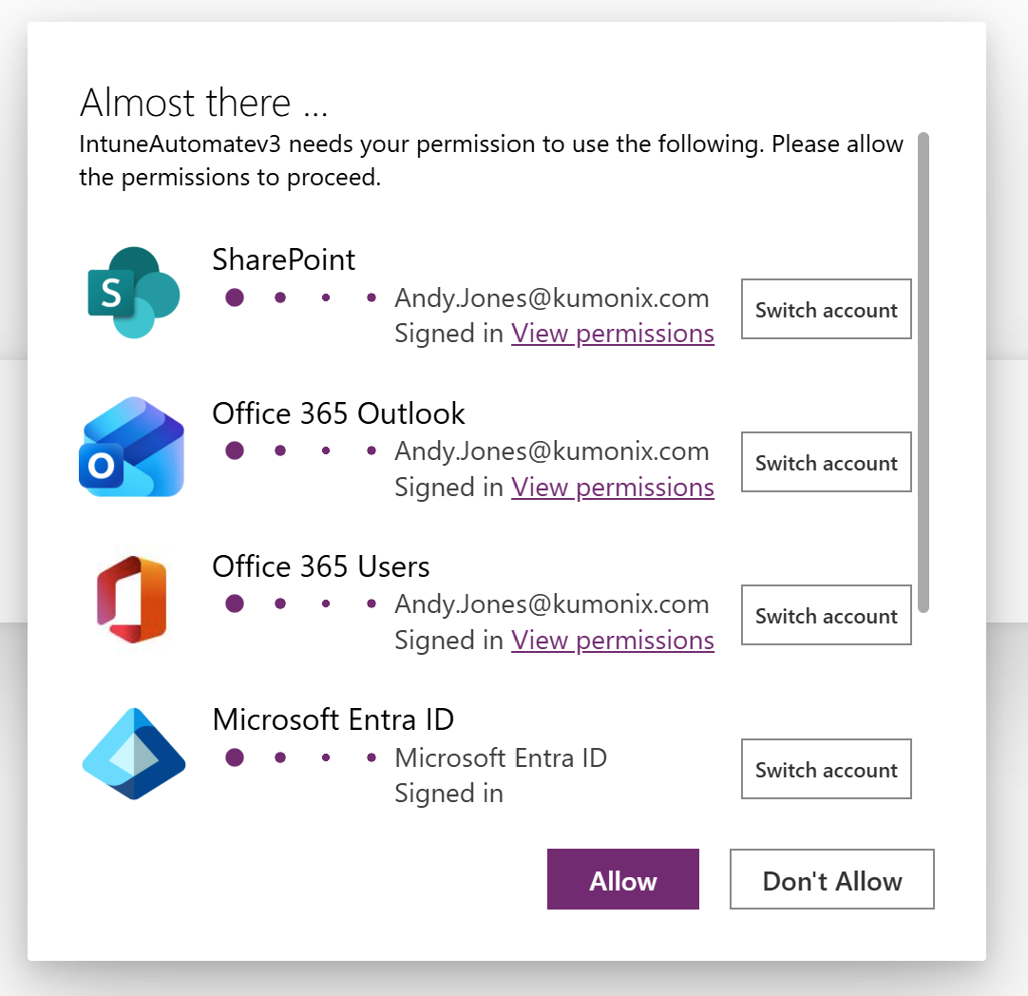
- Unfortunately, The PowerApp platform does not allow for an easy migration of Power App connection references. Therefore: Once the App first loads establish new connections within the App to the imported SharePoint Lists from your new SharePoint site just created within your own tenant. Switch to Power App Edit mode on the first loaded screen then add new data connections for the following SharePoint Lists: (When creating a new SharePoint connection you can simply check all the listed Lists and all screen error flags should disappear.
  - PowerAppReports
  - PersonaPacks
  - PersonaDeployments
  - Permissions
  - Onboarding
  - EnvironmentSettings
  - AutomateSettings
  - Asset Manager
  - AppSettings
  - Request Admin Access
  - AdminLanguage
  - App Request
  - DeviceRenames
  - UTCMDrift_Reports
  - AppSetup
  - UTCM_Monitors
  - EntraIHFGroups

- Now run the App and click – Get Started
- You will then be presented with the Setup screen below for your tenant environment.

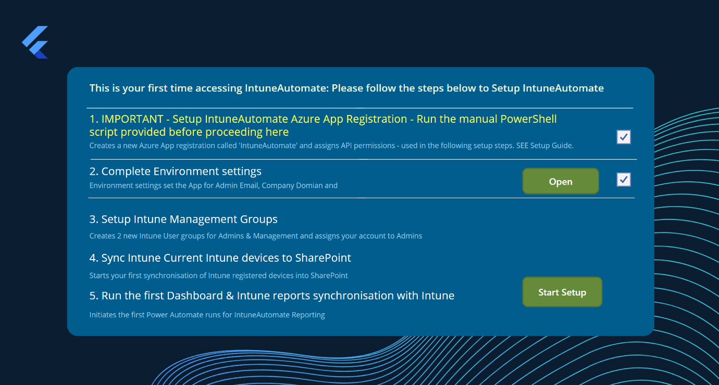

Step 1 – If you followed SharePoint and App Registration then the App Registration is already complete. If yes check the first screen box which opens the next step.
Step 2 – Open and complete the Environment settings then Check the box in 2.
Step 3 – Go into Power App edit mode again. Within the Power App page on the left click the … in the menu and select ‘Power Automate’. If you see any connections as ‘Not Connected’ click the … along side these connections and choose ‘Edit. This should open the flow. Check there are no flow errors and click the save button, then exit the screen ‘X’ and go back into Power Apps. Now refresh the connection, this should now show as connected.
Step 4 – Now Run the App again and Click ‘Start Setup’ to create required Intune groups and sync initial data from Intune into the App. Only do this once and wait.
NOTE: Running the ‘Start Setup’ multiple times will create multiple duplicate records within the ‘Permissions’ Sharepoint List so when restarting the app (next step) will not find your account to login.
Step 5 – The setup will complete with 15 seconds. Once the popup disappears. Close the App and restart it. The App should prompt to ‘Get Started ‘ again, click which takes you to the main Dashboard.
Step 6 – At this point you user credential has been added to the IntuneAutomate_Admin group created for you in Entra and you now have access to all (But Drift Management) Intune Automate features.
NOTE: UserAdmin Uplift is currently disabled as new Microsoft features have been released so this feature is being re-evaluated.
You now have access to:
- Device Rename
- Asset Manager (existing Intune devices should already be synchronised into the App.
- Application Requests
- Intune Reports with data syn’d from Intune for Licenses, Apps and Devices
- Persona Packs ready to go for the Finance Industry
- Automate settings (Click and see the settings you already submitted)
- Drift Management (Although you still need to set this up as a separate config – see further down)
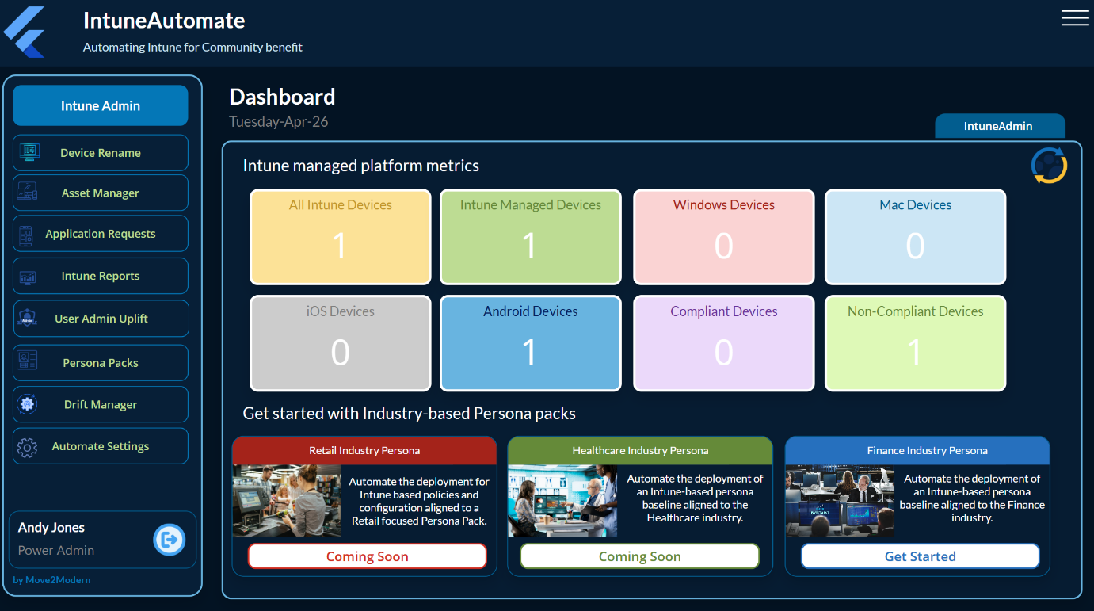

Power Automate flows & Power App (UTCM Went GA on 24-4-26 )
- Drift Management is a premium way of utilising a number of Microsoft’s UTCM features each bundled as resource types. With the recent UTCM release – IntuneAutomate includes its first and most stable Resource Type ‘Conditional Access’ drift control- With additional M365 and Intune Resource Types already planned following this announcement. UTCM is a powerful way of monitoring and baselining your Conditional access (CA) policies. With the importance and security CA brings, monitoring this in your own environment could be essential.
- To get started you will first need to create a ServicePrincipal as required by UTCM and add the associated permissions assigned for the different Resource types. If you decide it’s an IntuneAutomate feature you would like to include follow these steps.
- Drift Management PowerShell setup steps.
  - Download PowerShell 7 scripts locally from GitHub https://github.com/Croxleyboy/IntuneAutomate/OneoffPowerShellScripts
  - As a Global Admin open the PowerShell 7 console, navigate to the download folder for the PowerShell scripts and run scripts (1-4) one by one in the provided order ensuring they run successfully each time:
  - As a check you can also run the following PowerShell to check through the status of a SP, snapshots and Monitors.
    - ‘.\ServicePrincipalPreCheck’
Run this pre-check to establish if a service Principal already exists. As you can see here a SP was found and reported.
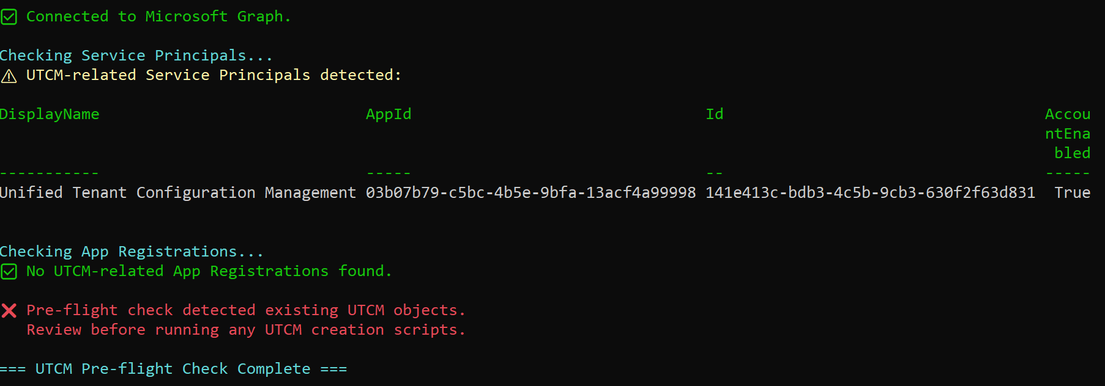

    - ‘.\UTCMInventoryAndDeleteOption’
You can also run this script to check for any existing UTCM Snapshots and Monitors and if required will provide the option to delete ALL of these as required. This gives you a heads up on what you have currently setup.

  - With this complete run through the UTCM setup.
    - ‘.\1-CreateUTCMandM365ServicePrincipal-OneOff’
Only run this if a SP doesn’t exist
    - ‘.\2-GrantPermissionsForCAandIntuneresourceTypesV3’
Only run this if permissions for a CA resource type doesn’t already exist. This will grant permissions for both -
1. The UTCM service principal (snapshot/monitor/drift operations)
2. The UTCM-Automation Managed Identity (SharePoint list read/write for runbook)
  - Now Create the first UTCM Snapshot and Monitor for CA (This is your first conditional access baseline and drift Monitor that checks for drifts every 6 hours)
    - ‘.\3-New-UTCMCASnapshot’
    - ‘.\4-New-UTCMCAandIntuneMonitorSetup’
You will be prompted for your Domain or Tenant ID
You will be provided with a summary of the results:

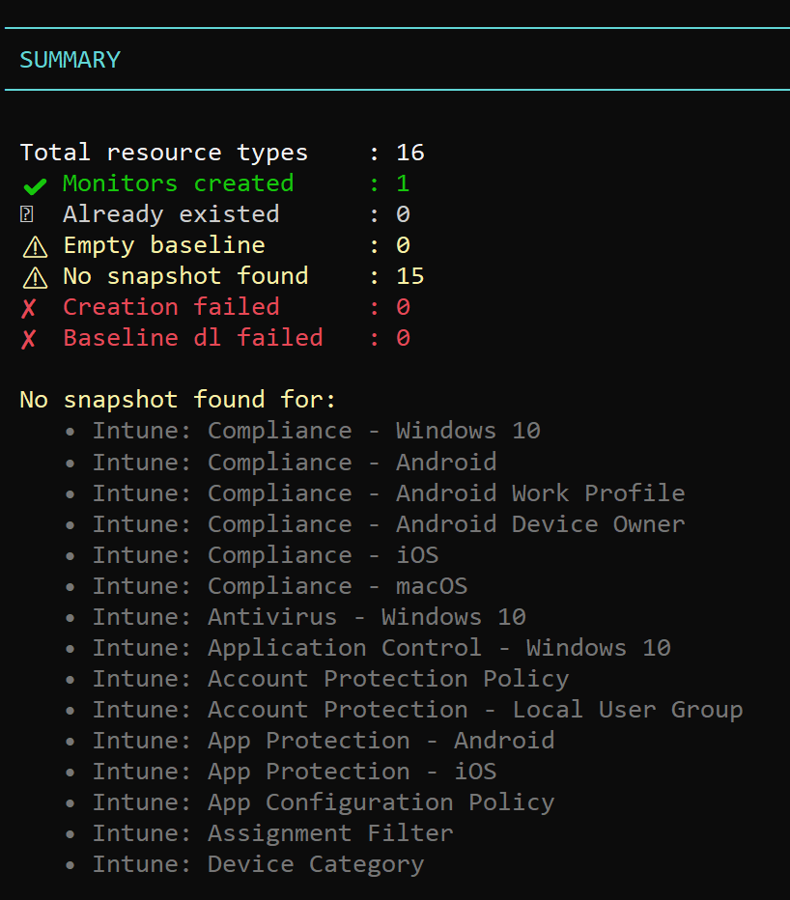

And the monitor should appear within Tenant Governance (within Entra.microsoft.com

  - Now check your monitor has been created within your Entra portal (https://entra.microsoft.com) > Tenant Governance (preview) > Monitors (Preview) > Monitors

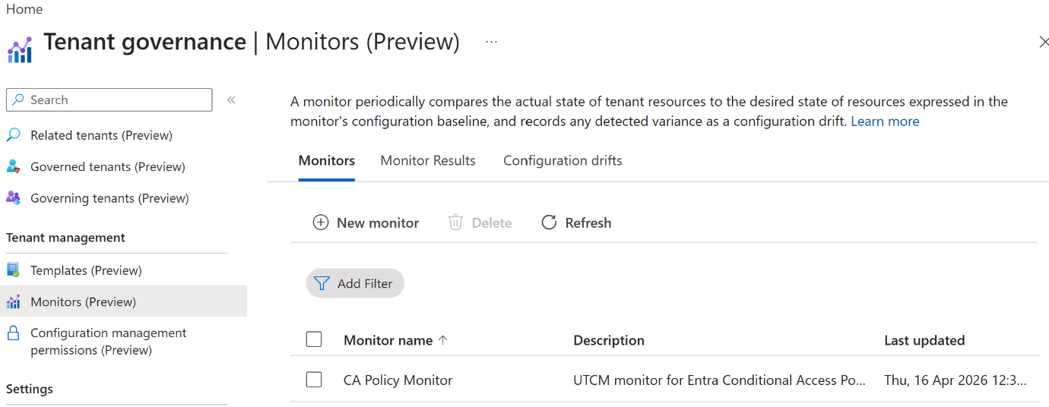
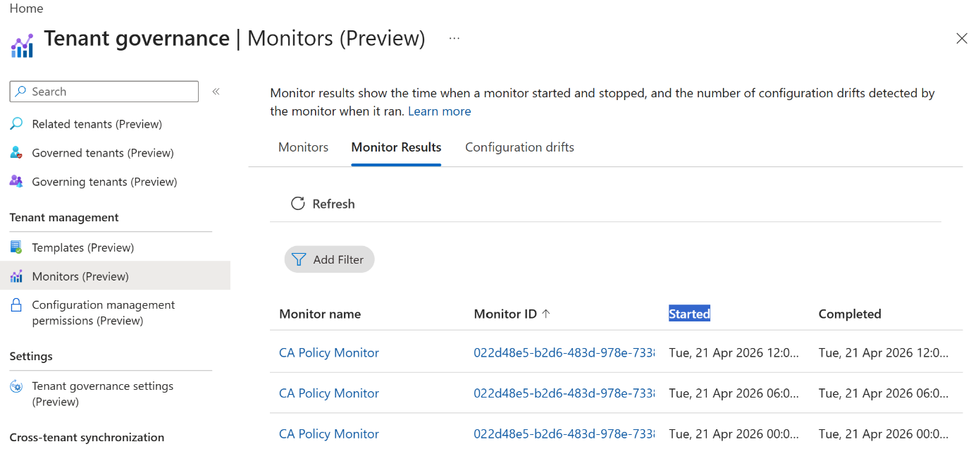

  - The Configuration drifts will be empty (unless you already have this setup previously ) but you can check back here also as drift occurs.
  - NOTE: Please avoid running the creation of a Monitor multiple times as UTCM allows multiples Monitors to exist but the script will most likely fail and has been designed to maintain one monitor per resource group. Multiple resource types will be add as they become more stable.

- Drift Management Runbook setup steps.
PLEASE NOTE: Running runbooks with automation accounts can use Pay-As-You-Go consumption within your Azure tenant.
  - Next up is the creation for an Azure Automation account and x2 associated Runbooks to schedule the detection of drifts and update IntuneAutomate. Steps:
    - Login to your Azure portal and create a new Resource Group called ‘UTCM_ResourceGroup’
    - Create a new automation Account inside the Resource group –‘UTCM-Automation’
    - Inside the Automation account - Create a new Runbook called – ‘Intuneautomate_UTCM_DriftAndMonitors’
    - Copy the Script details from the downloaded file ‘Runbook1-DriftManager’ and edit the Runbook, Including adding a schedule to run every 6 hours (which is every time UTCM creates new output)
    - Create another Runbook called ‘Runbook-UTCM-CA-Rebaseline_v1_0’ within the same resource group. NO schedule required. This runbook is used for re-baselining CA after drift has occured and can automatically initiated from the App. Edit and save the runbook with content from the downloaded ‘Runbook2-ReBaseline’.
    - NOTE:Please remember to Publish the Runbooks
  - Drift Management - Power Automate part
    - Once the UTCM has been setup with Conditional Access configured with a Monitor and Runbook, there are x2 Power Automate flows supporting this feature
    - ‘App - Create new UTCM ReBaseline’ – This flow is initiated via the Application and sends requests to the Runbook - Runbook-UTCM-CA-Rebaseline_v1_0 to delete old Snapshots and Monitors for CA and recreate them (basically re-baselining the Resource Type.
    - ‘Scheduled - Create UTCM 6Hour report’ – This flow is scheduled to run every 6 hours and picks up monitor updates from the scheduled Runbook - Intuneautomate_UTCM_DriftAndMonitors – The Run book updates Share points lists as shown in the PowerShell and creates a new HTML Report which is used for the Drift Manager feature in IntuneAutomate App.
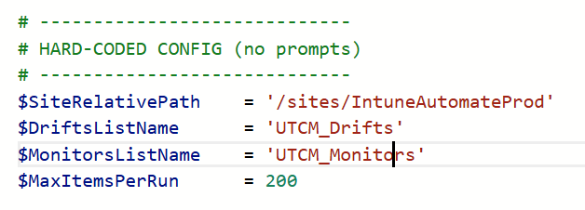

The result is the output to the Drift Management feature within the App.
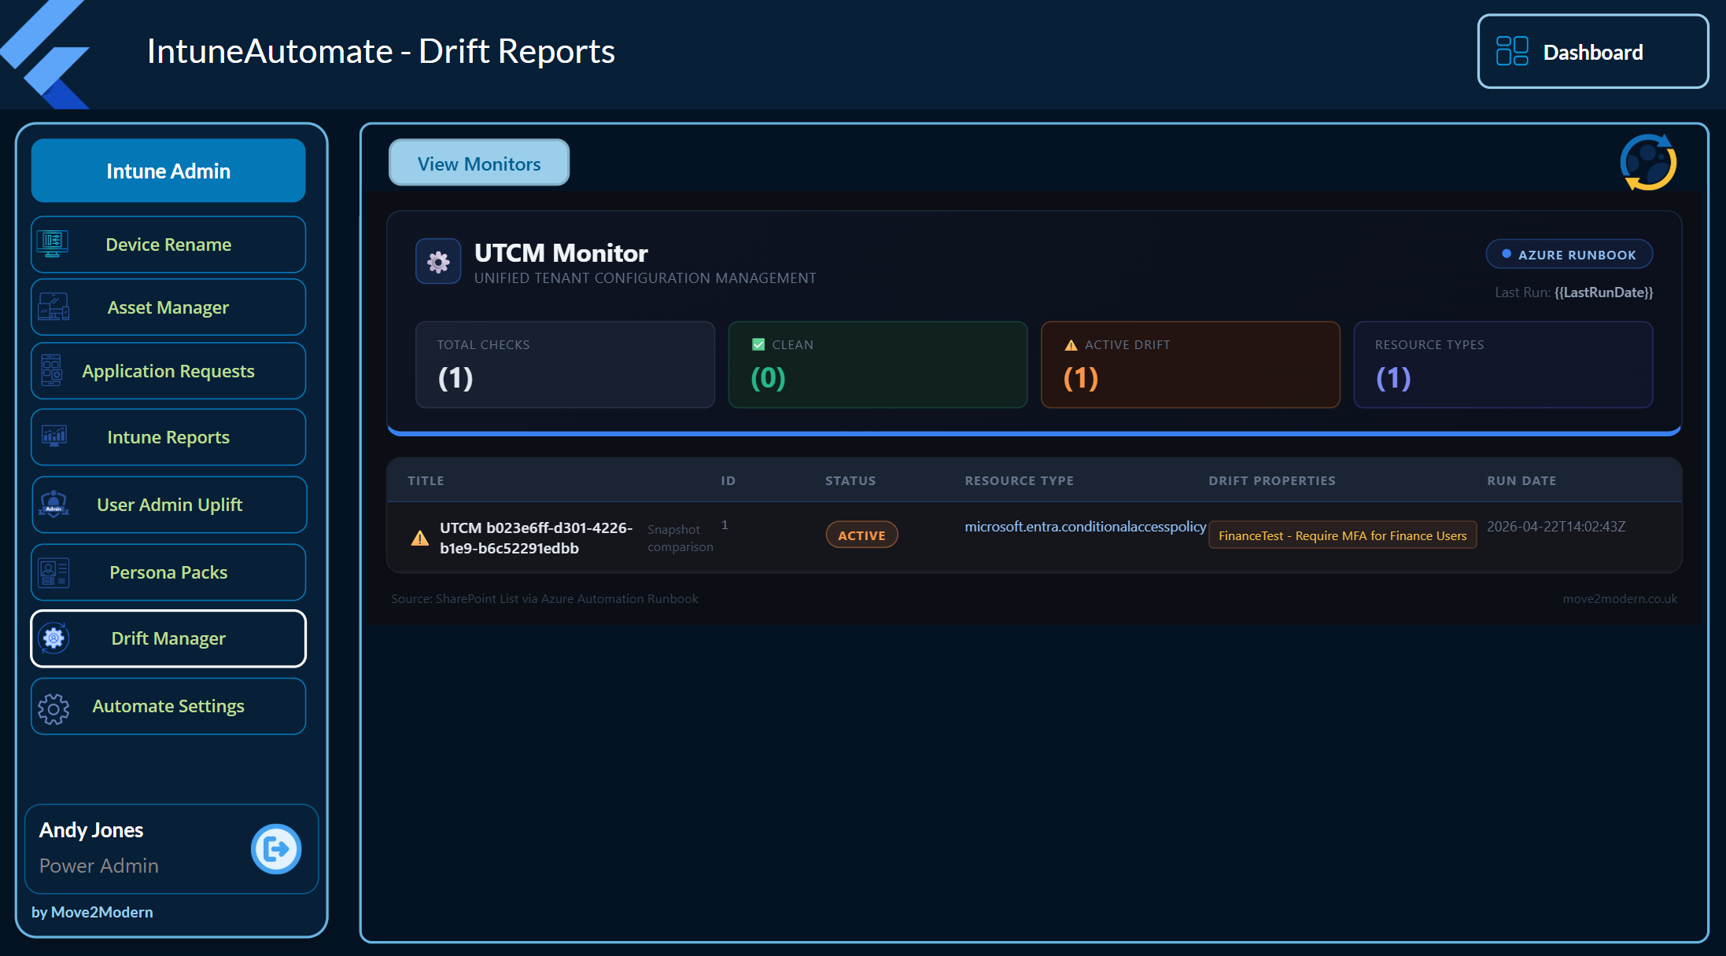

Power Automate Flow reference
These automation flows should be imported and are either initiated to run through the Application or will run on a schedule to update data from Intune into SharePoint. Please go in and change the schedule of the flows to meet your own update requirements.
Do Not: Change the flow’s trigger linked to the application otherwise these IntuneAutomate features will stop functioning.
